CS 255 System Design – DriverPass Design Doc

UML Diagrams

UML Use Case Diagram
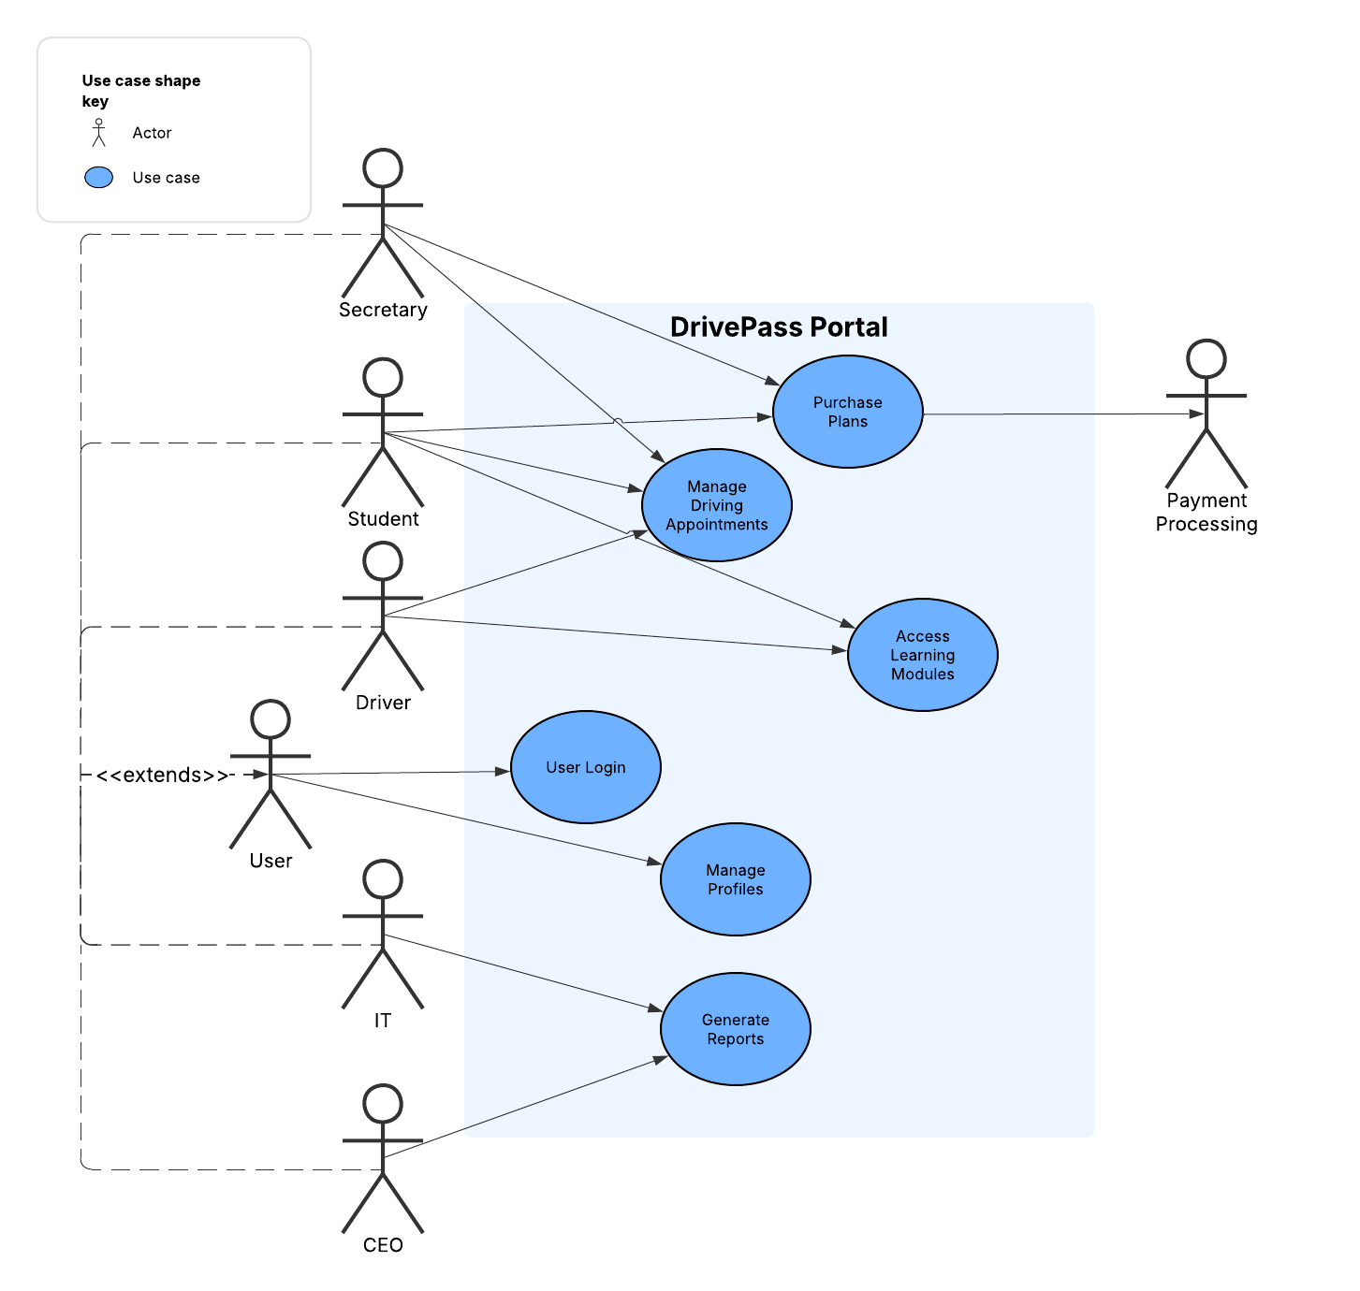
This diagram illustrates which users have access to which portions of the overall system. All users need access to User Login and Manage Profiles (for creating, updating, or deleting their profile). Every other actor represents a specific type of user and the diagram shows which users access which pieces of the system. Additionally, since payment will be handled through an exterior processor, they are listed as a secondary actor that interacts with the system.

UML Activity Diagrams

Manage Driving Appointments Activity Diagram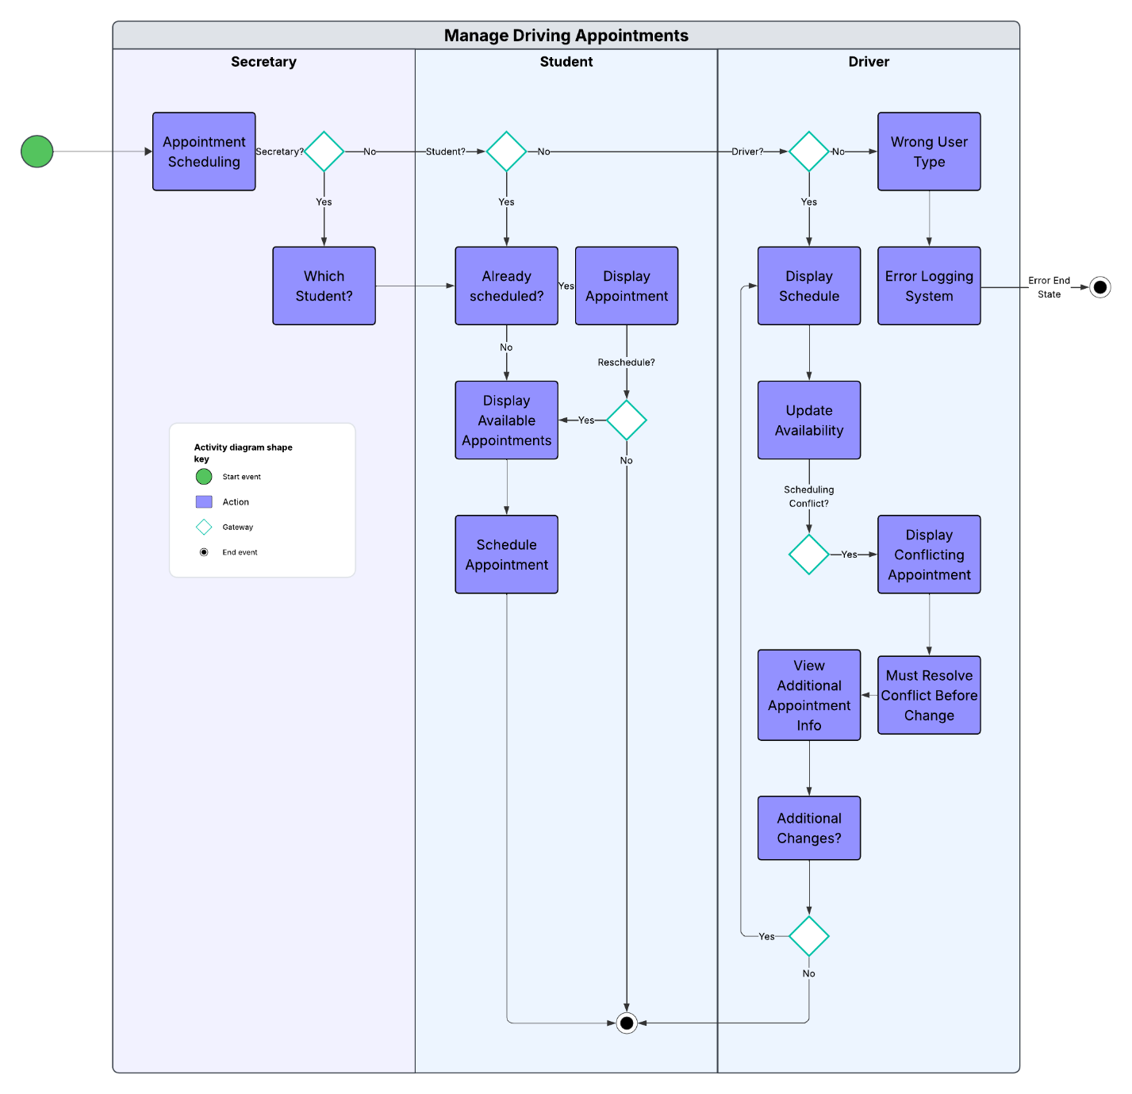
Three different user types have access to the appoint scheduling portion. The secretary is only scheduling appointments on behalf of students, so there is an additional step of checking which student profile needs to schedule an appointment. Students may only schedule one appointment at a time, as the instructor will need to see the progress level of the student to decide what session to schedule next. Instructors can change their availability, but if a session has already been scheduled, they must go through the process of canceling or rescheduling that appointment before the system will allow them to remove that availability. If a user other than secretary, student, or driver has accessed this process, either a computer error has taken place or an unauthorized user is navigating the system, so it exits to a system logging and security flag.
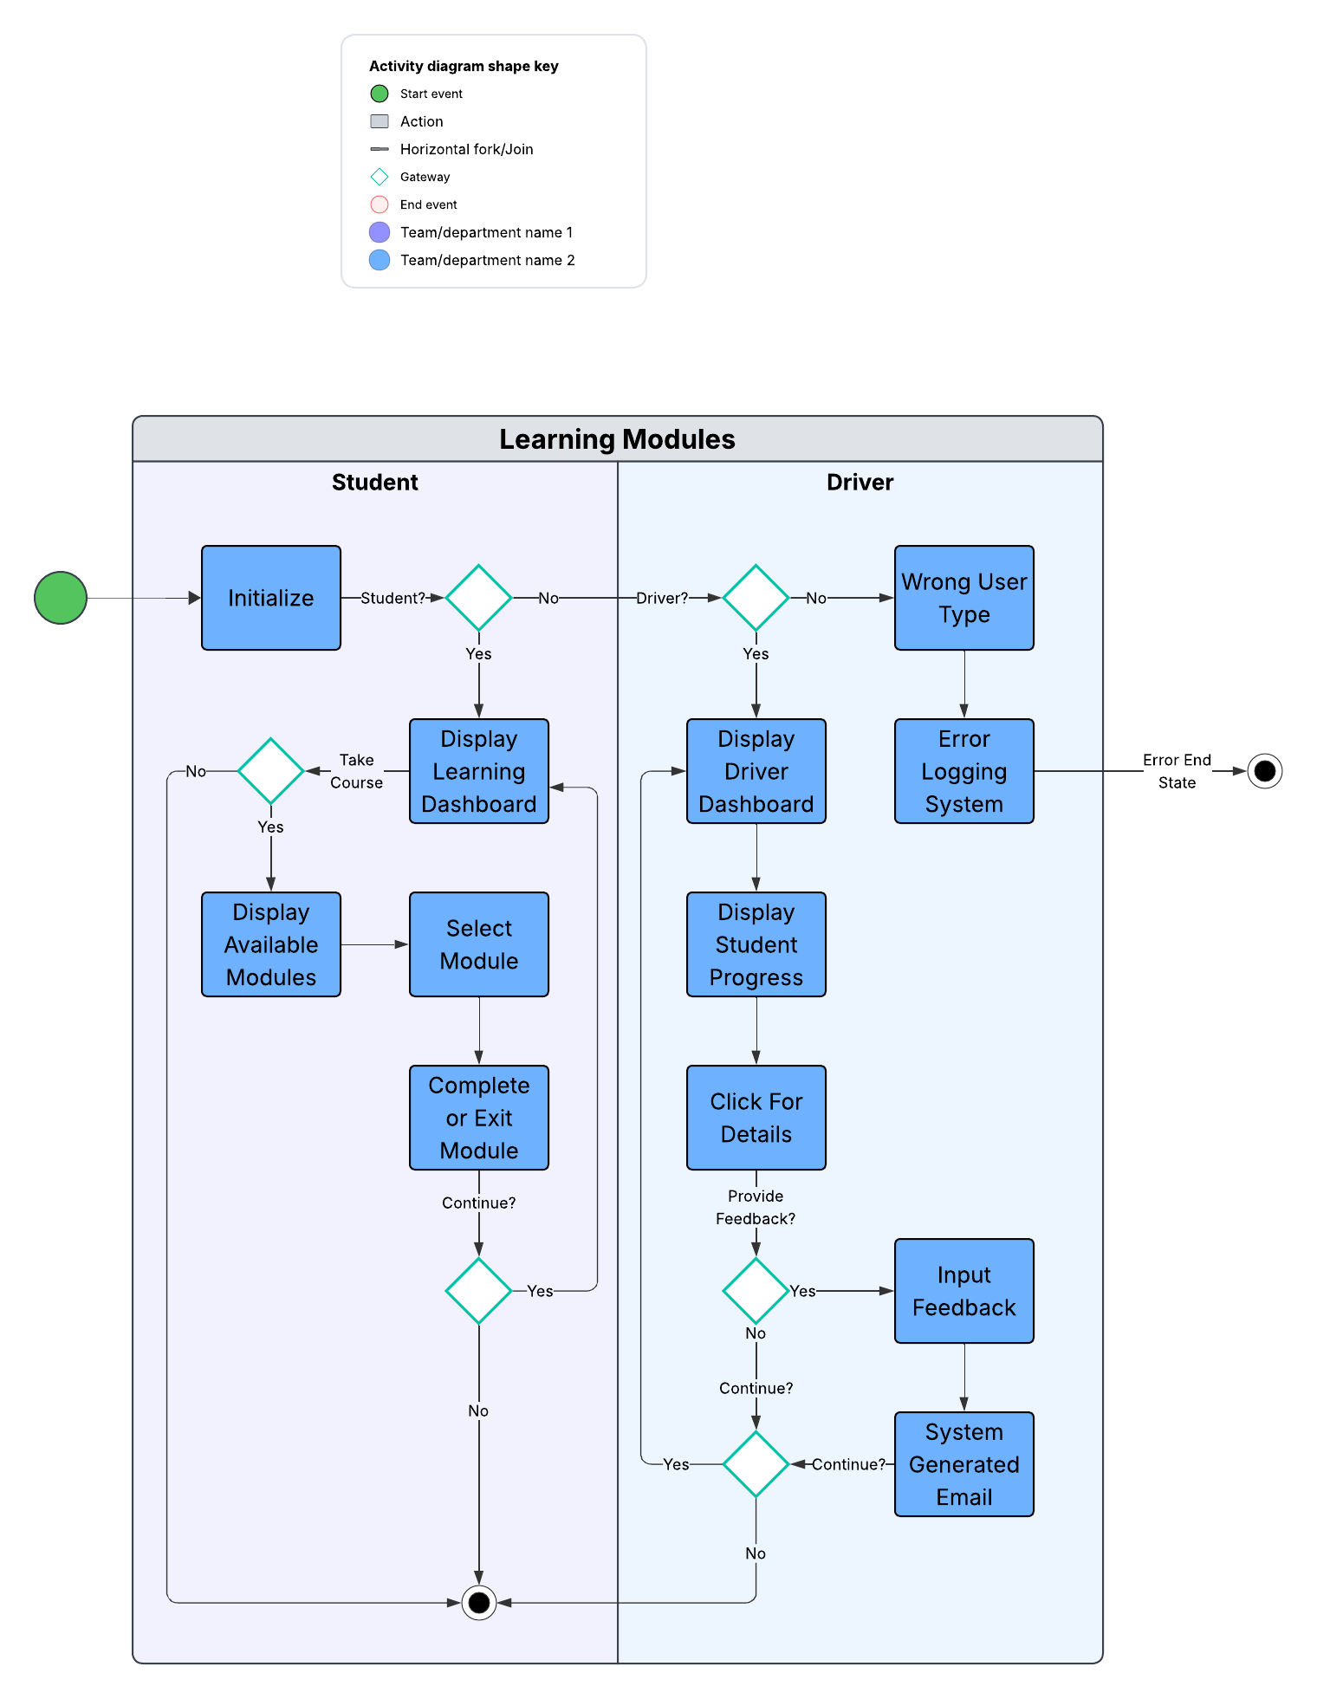
The system tracks student progress through various learning modules, quizzes, and reviews. Students have a dashboard showing their learning journey. They may select any module and completely or partially complete that module in a single sitting. If they wish, they can continue back to their dashboard for additional learning.
Driving instructors have a separate dashboard listing each of their students and their percentage of completed modules. They may click on any student to see additional information about their individual learning modules and previous driving sessions. The instructor may add or update feedback on the driving lesson, any individual lesson, or just general feedback for the student. The student is emailed if they receive new feedback and may read it either in their email or from their main system dashboard.

UML Sequence Diagram

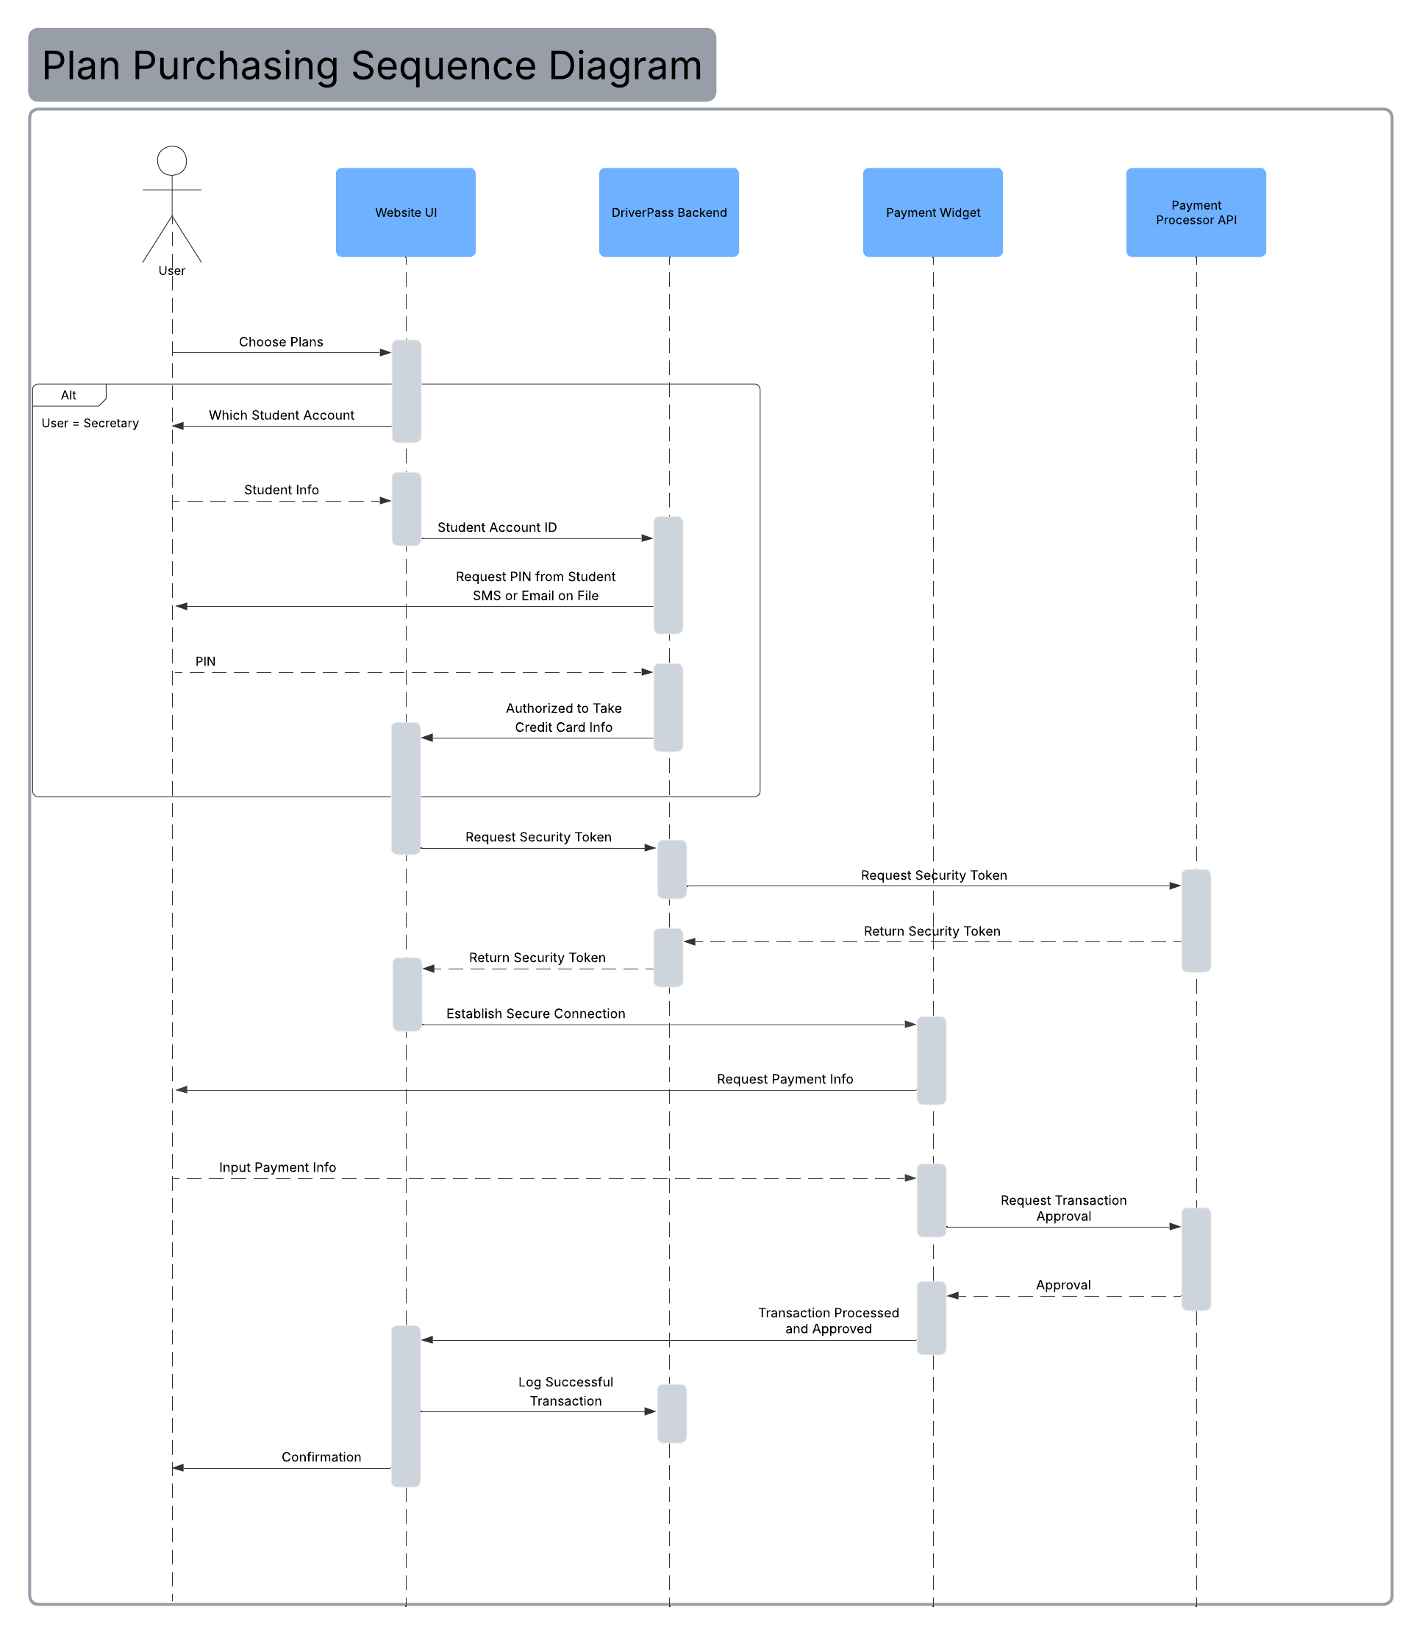
The payment processing is the best selection for a sequence diagram. It is the only Use Case that involves communicating with an outside system and has additional security concerns because it involves financial transactions. This is all handled automatically on the back end, and the customer doesn’t have to understand its every detail, but it shows the customer that serious thought has been put into building security into their system at the architectural level.

UML Class Diagram

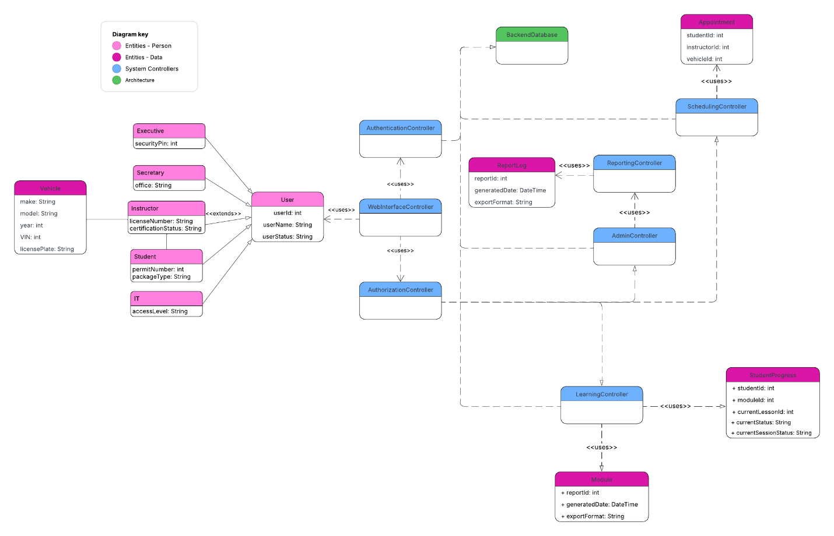
Here we have the main system architecture. I have it centered around a WebsiteInterfaceController that is the web portal and how users interact with the system. It routes login attempts through AuthenticationController. I don’t have “password” or “username” as a field anywhere for security purposes. Login attempts will be handled directly through the AuthenticationController and the Backend. All attempts to use any of the primary system modules must be handled through AuthenticationController to ensure functions can only be accessed by Users of the appropriate type. To keep the diagram readable, I don’t have information on what fields are present in the BackendDatabase and the only helper objects I’ve included are:
- Module, for the modular lessons
- StudentProgress, for an object assigned to each student tracking all of their lesson progress
- Reports, which only holds the ID, date, and export format of the reports. The actual contents of the reports themselves would be stored in the database.

Technical Requirements
The project will require several different types of technical requirements.
- Hardware: Servers will be housed virtually through a cloud-hosted application, such as AWS. A database storage instance should also be secured, decoupled from the main server for added security and encapsulation. All users, staff and students, will be able to access the system through any desktop or mobile device with access to the internet.
- Software: IT should familiarize themselves with Ubuntu, an open-source Linux based operating system, to provide routine maintenance to the server. Additionally, IT may wish to access the database directly via MySQL, though the database will not be directly editable through MySQL for logging and data integrity reasons.
- Tools: An IDE environment, such as Eclipse. A tool for monitoring system logs. GitHub for tracking and logging any system changes.
- Infrastructure: Cloud architecture with scalable computing layers to allow the system to grow. Automated data backup. SSL/TLS certificate handling. Integrations to handle third-party API endpoints (for payment processing, or any later additions to the system).

